**Database Management System**

**(Lab Task No 01)**



Session (2022-2026)

Program/Class

**BS-Computer Science / 5rd Section-A**

Submitted By:

Student Name: Shaheer Ali Roll Number: 301-221044

Supervised By:

Ms. Muneeba Darwaish

Lecturer

CS& IT Department

**Hazara University, Mansehra**

Steps to Download and Install the MySQL server and Workbench.

**Step 1:**

First of all I downloaded the Setup from official website.

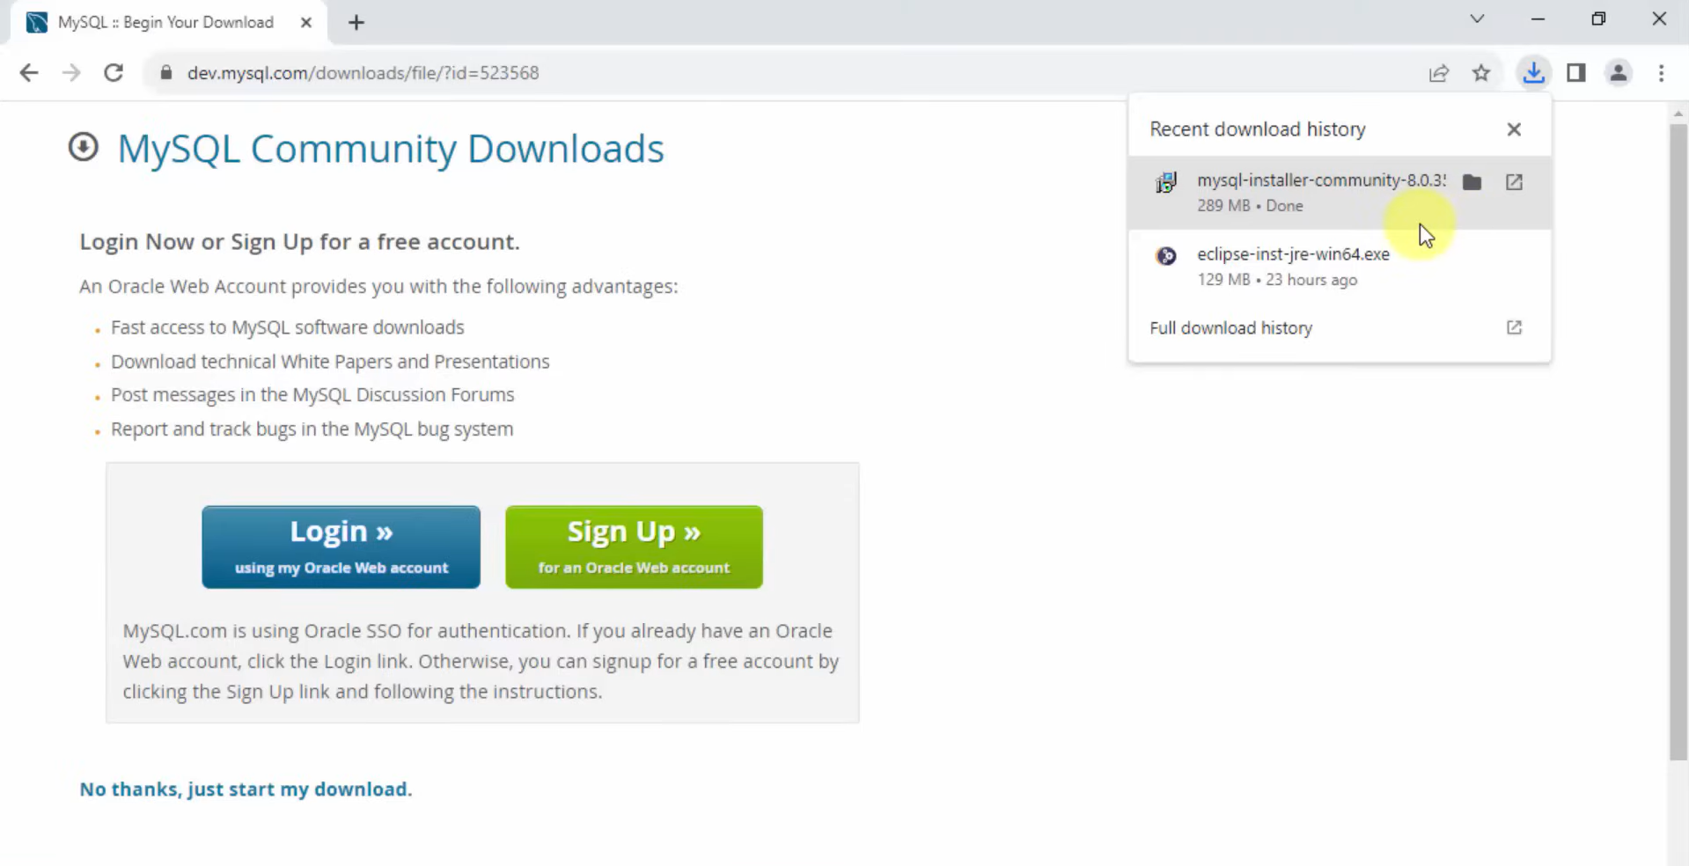

**Step 2:**

Then here I selected the custom and then clicked on next.

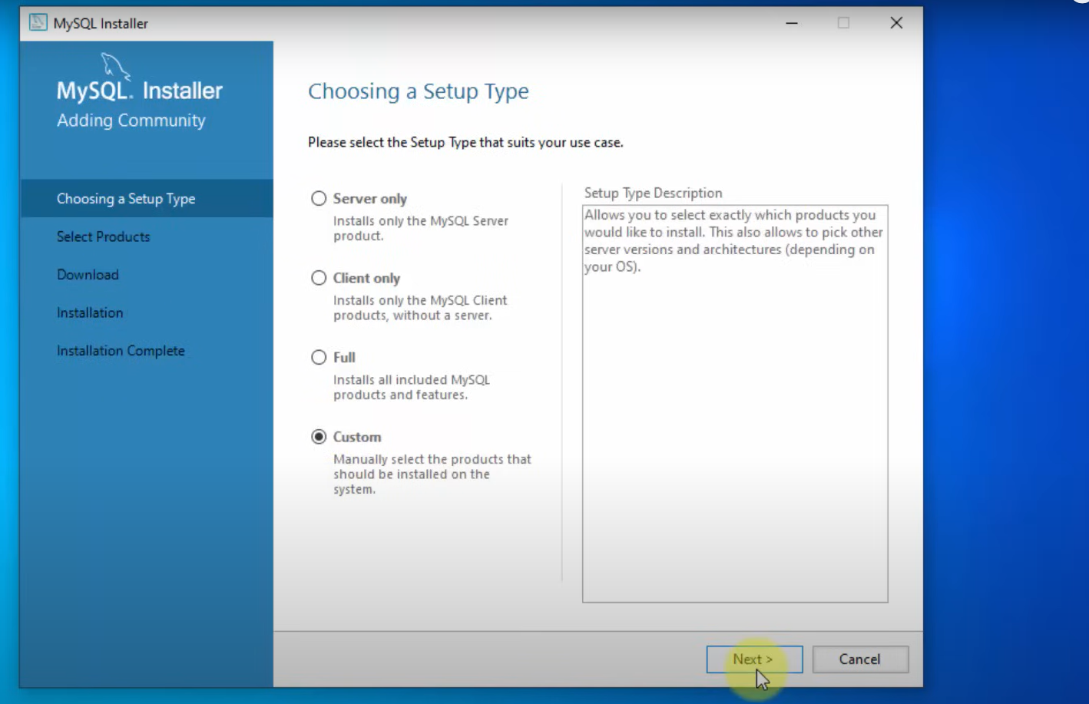

**Step 3:**

Here I have selected

1.MySQL Server 2. MySQL Workbench 3. MySQL Shell

and clicked on next,

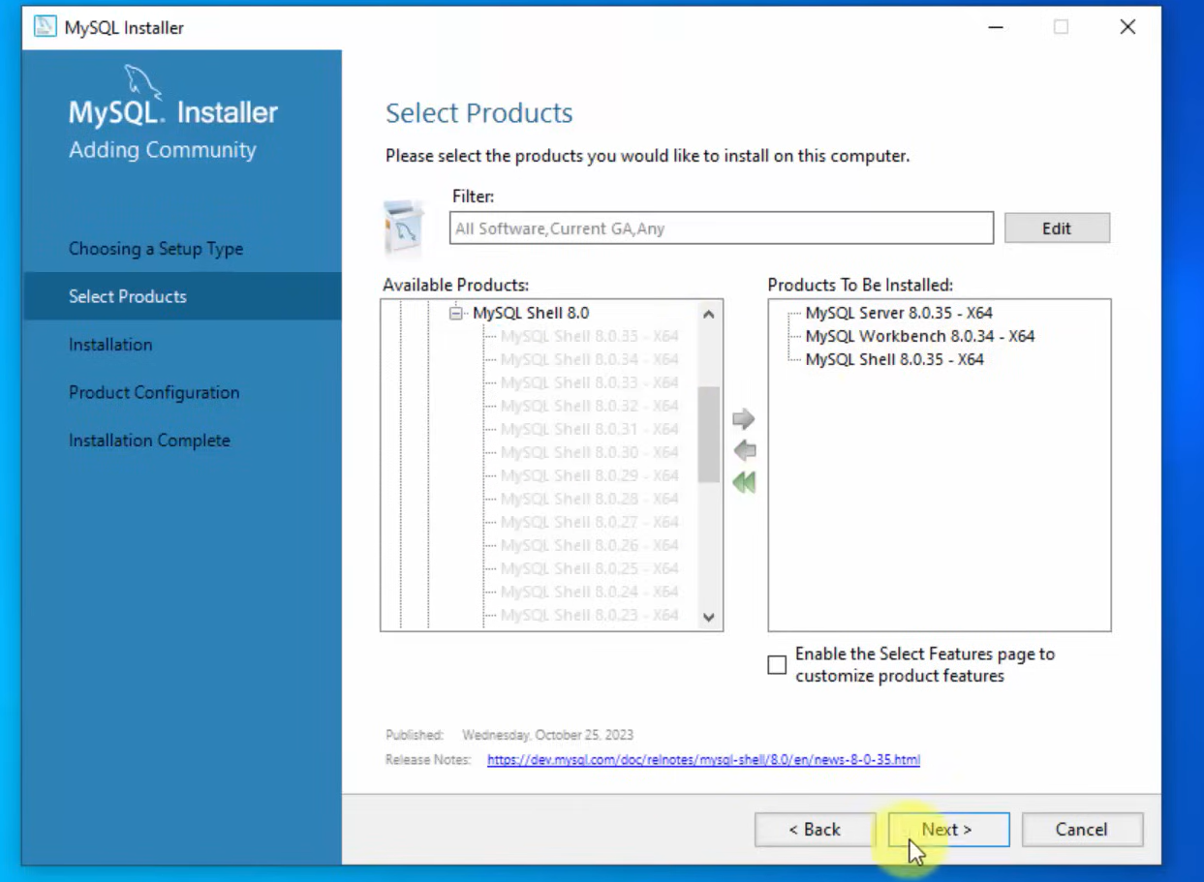

**Step 4:**

Here the selected items are installing

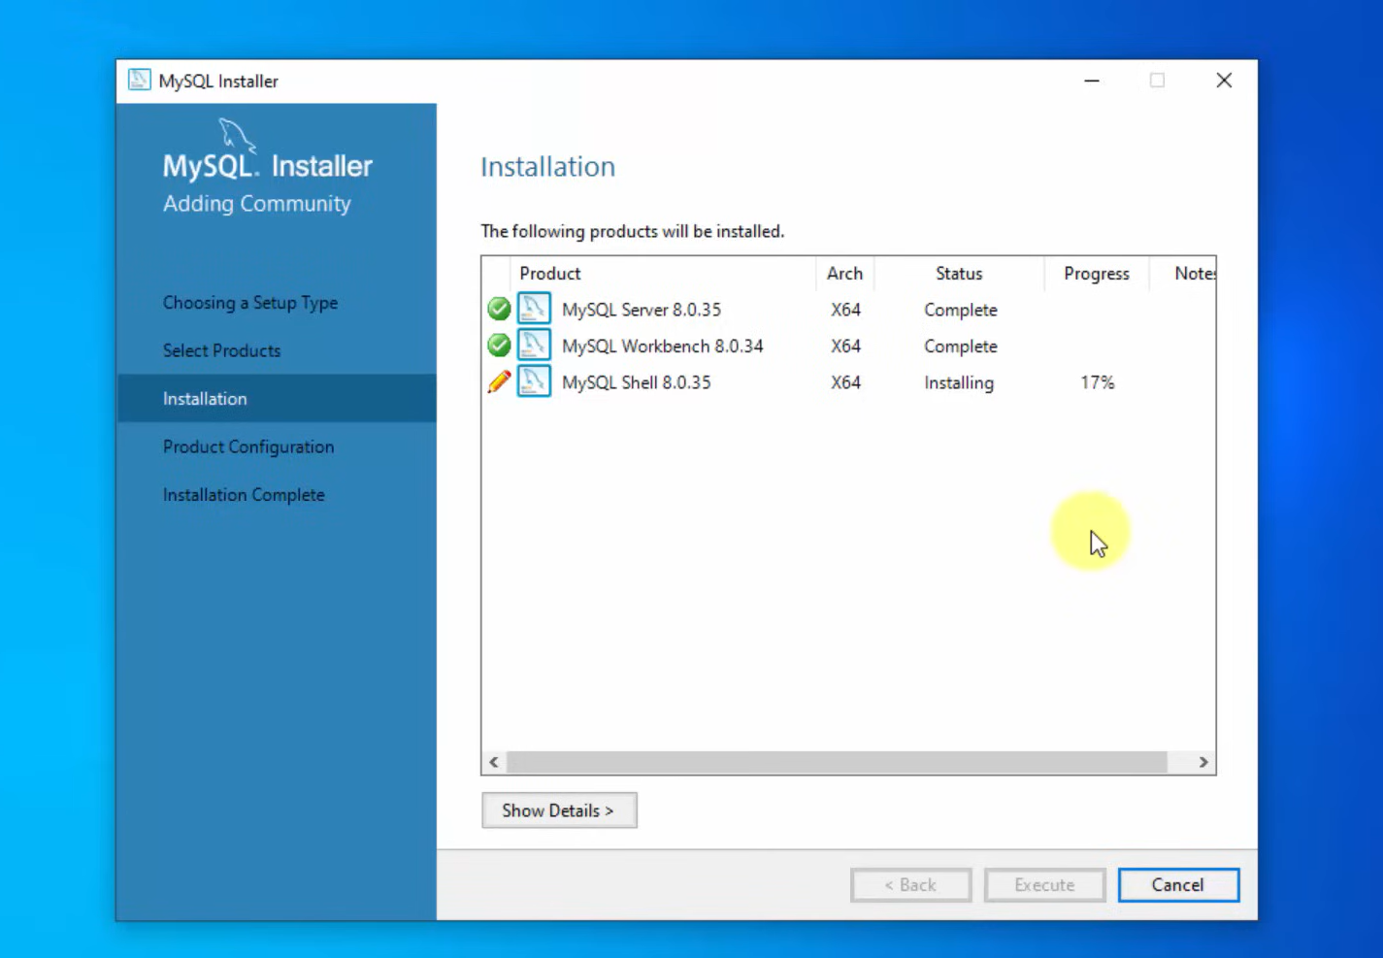

**Step 5:**

Here It moved forward for configuration, clicked on next,

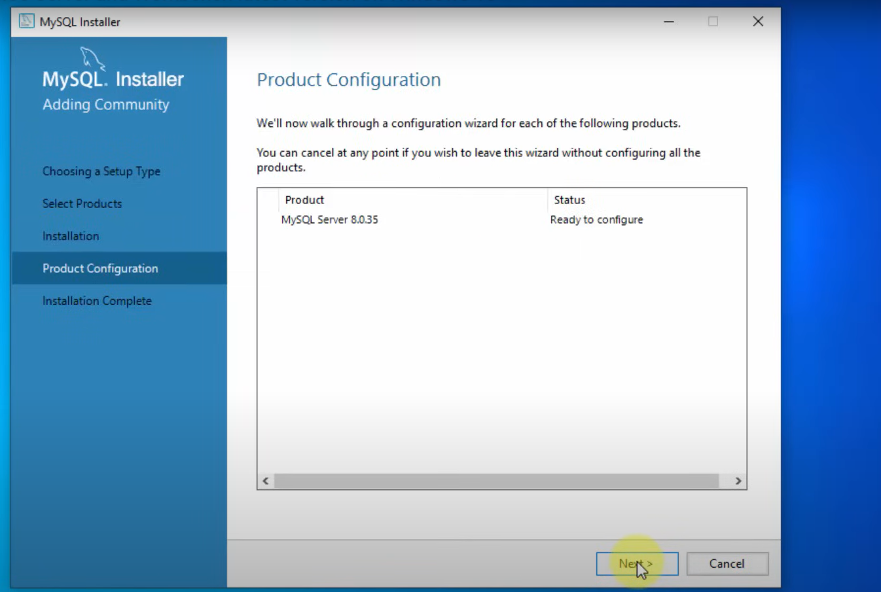

**Step 6:**

Clicked on next, I have leaved the setting by default,

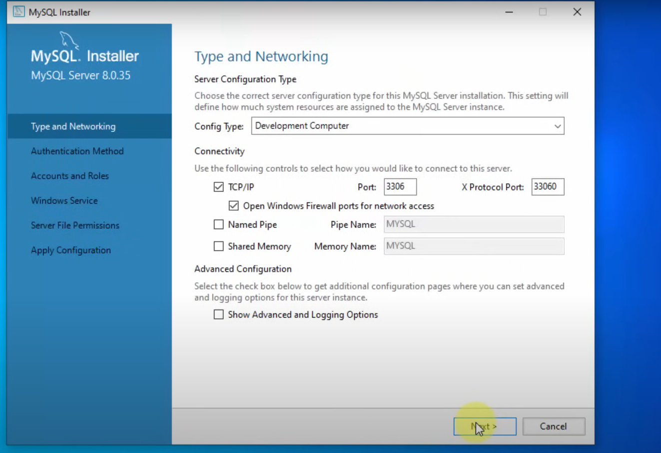

**Step 7:**

Next,

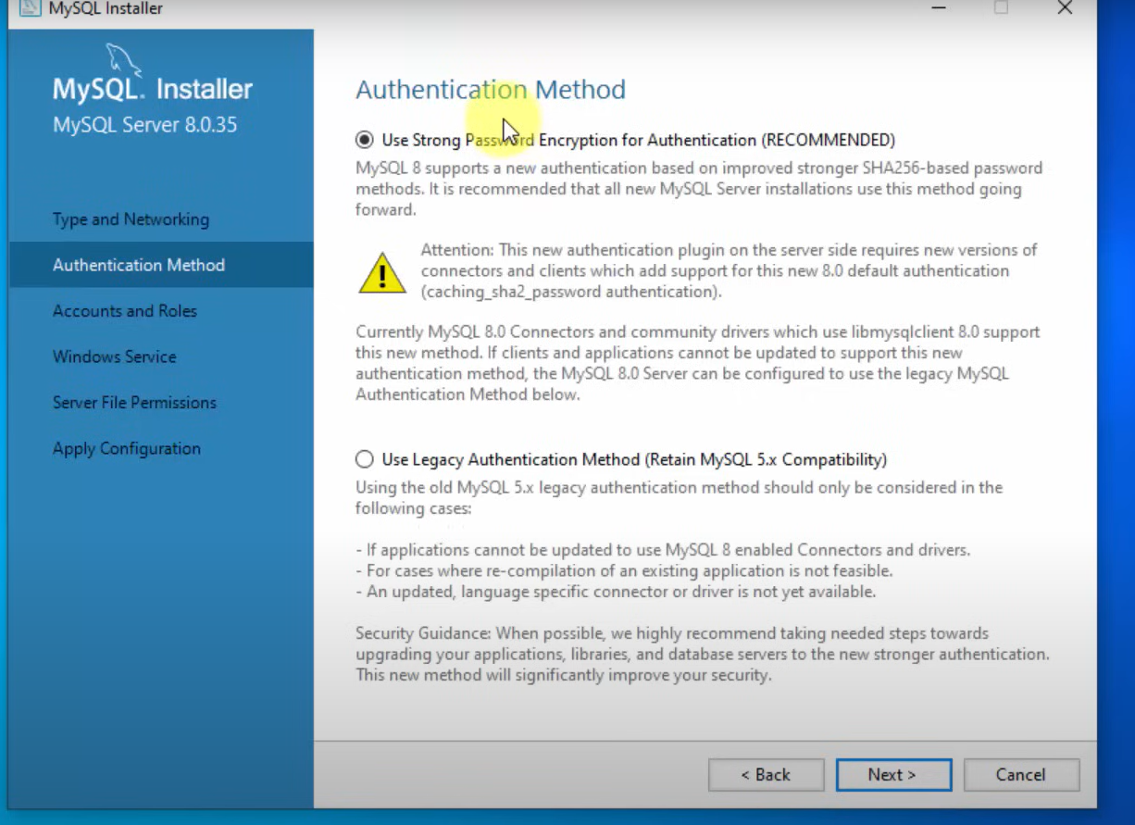

**Step 8:**

I set a strong password for the server,

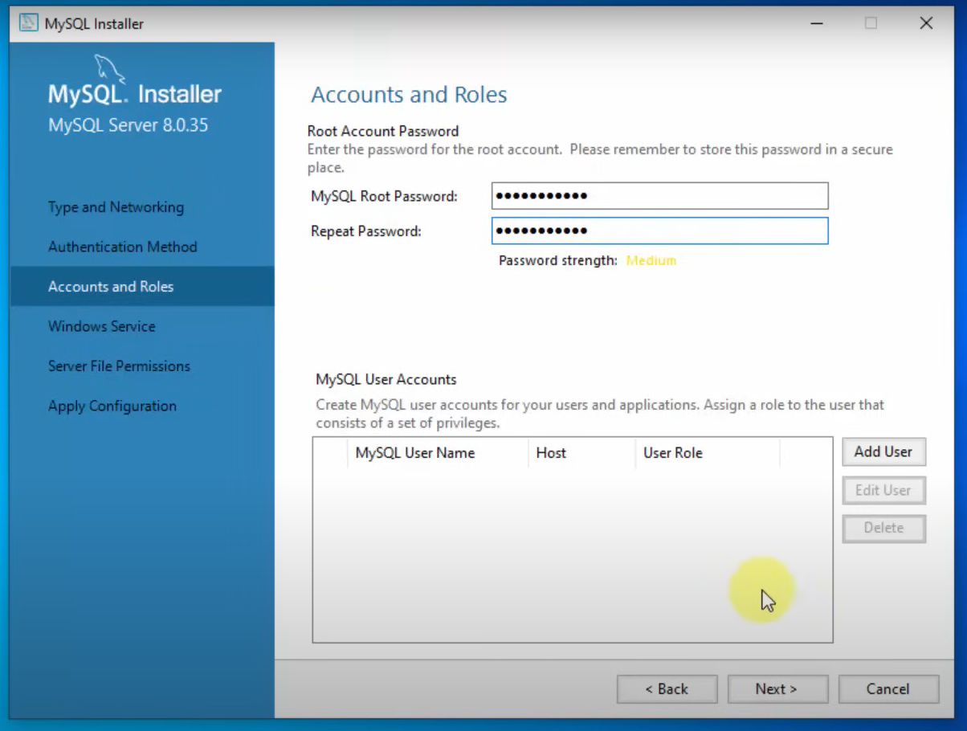

**Step 9:**

Next,

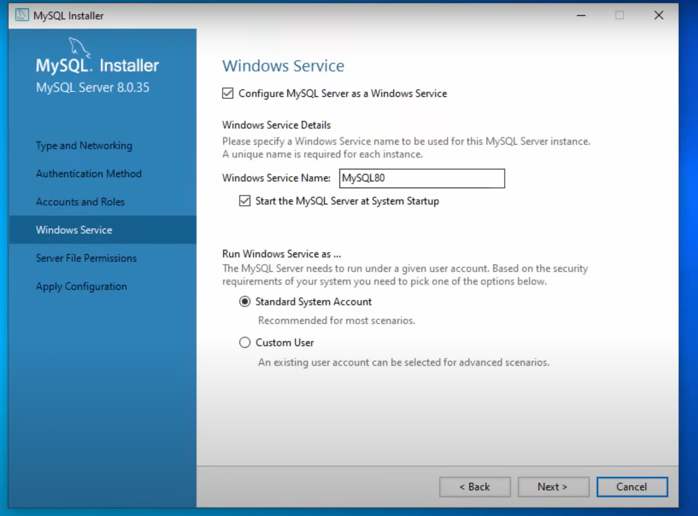

**Step 10:**

I grant access and then clicked on next,

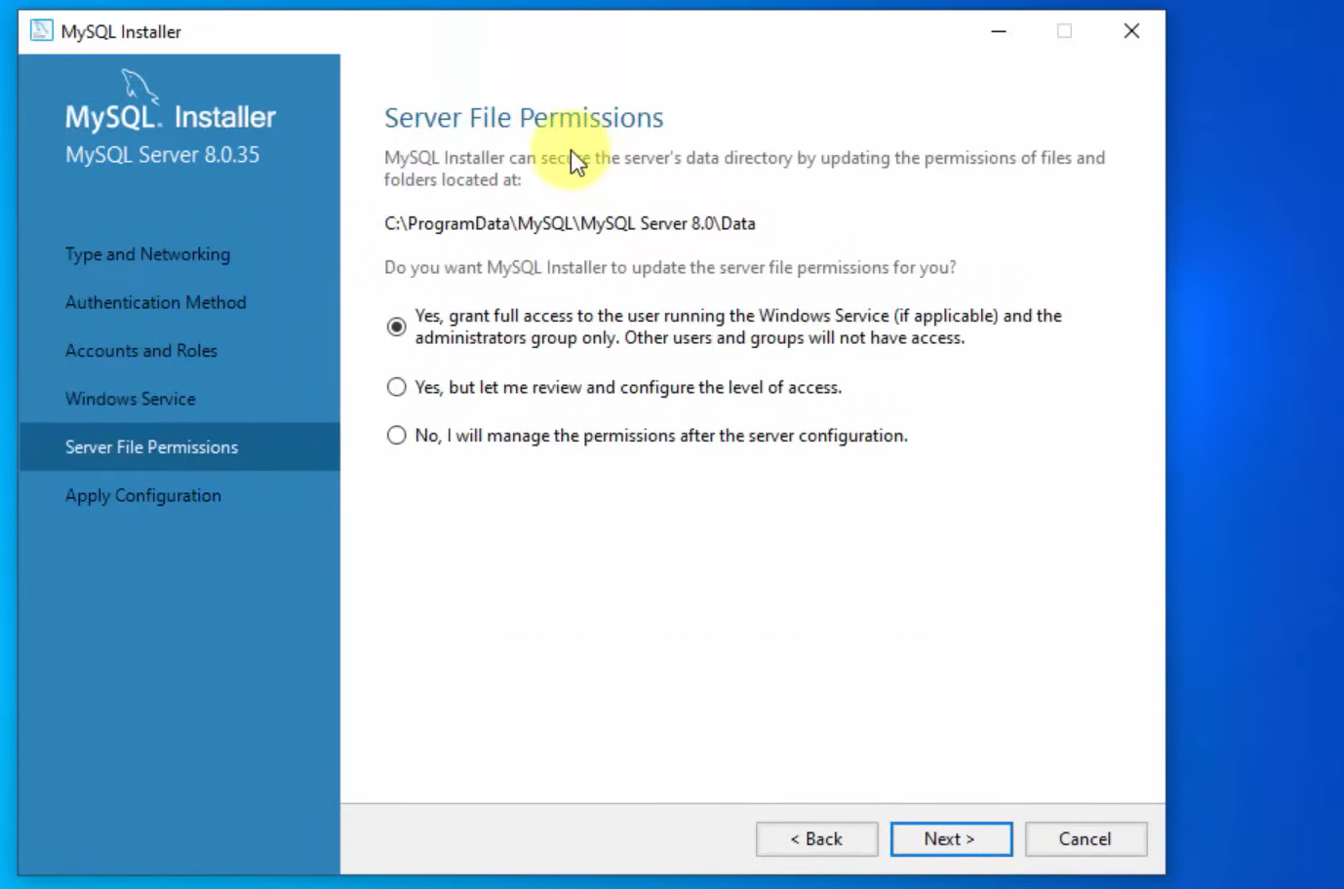

**Step 11:**

Execute,

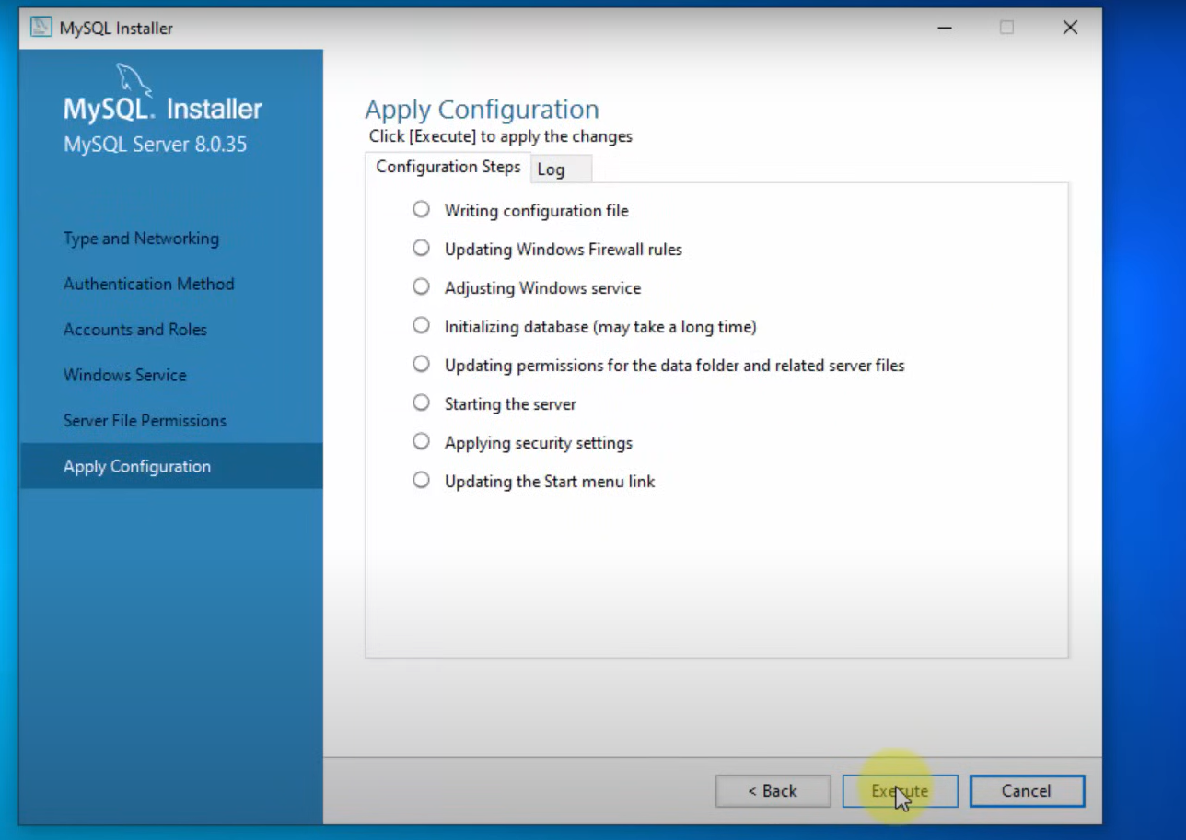

**Step 12:**

Execution has been finished,

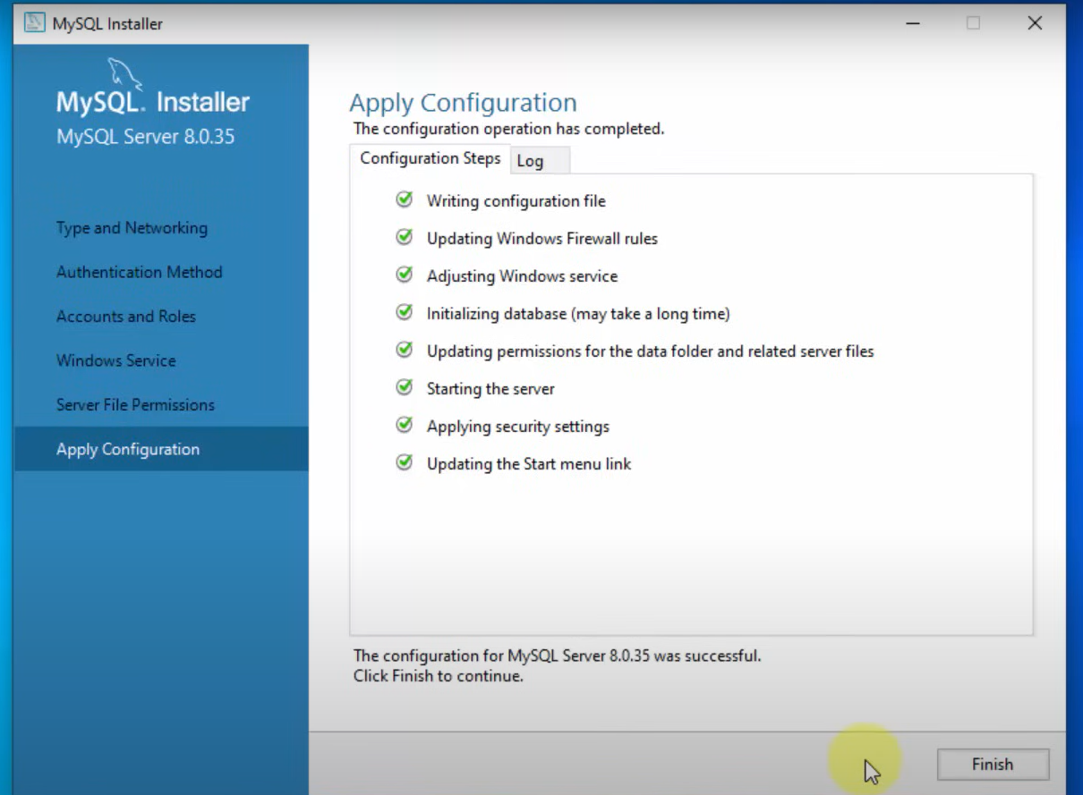 **Step 13:**

Next to move forward,

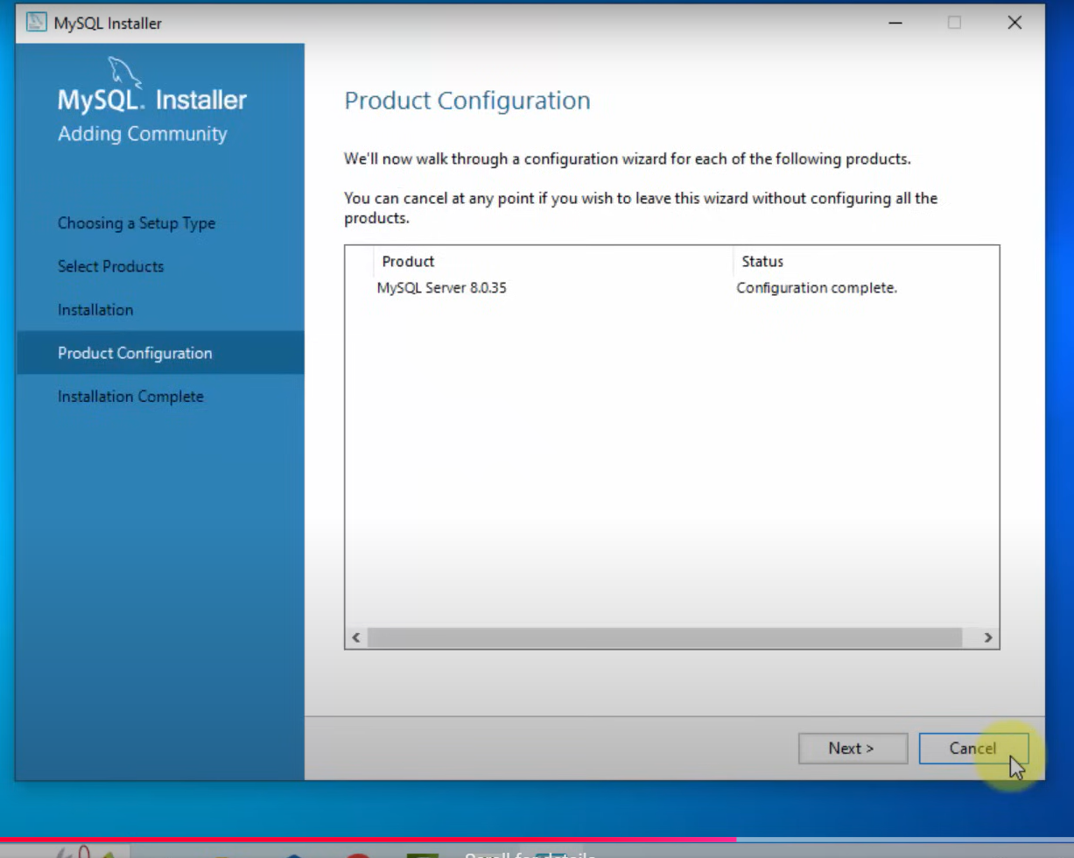

**Step 14:**

The installation is completed in this step, lets open the app,

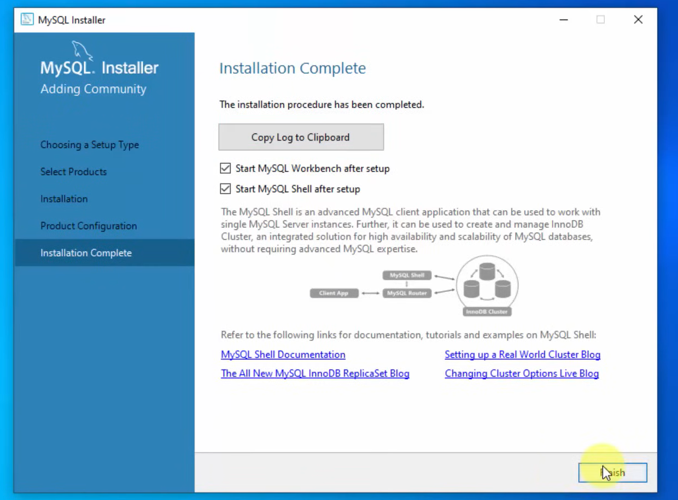

**Step 15: Open My SQL WorkBench:**

